Tour code: 4Day3Night
Hatyai, Songkhla & Phatthalung (HPTL-04)
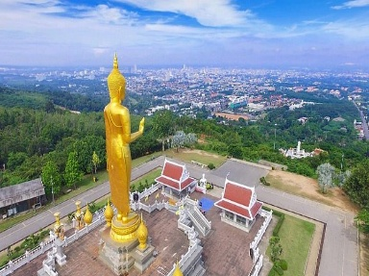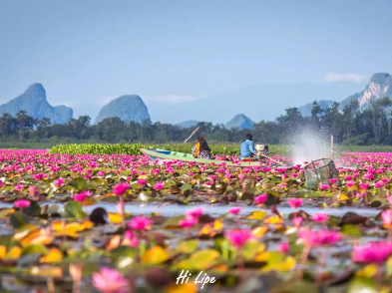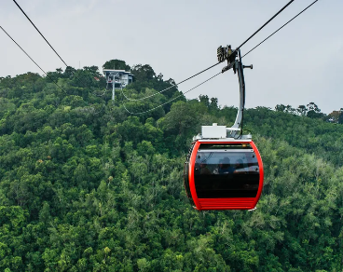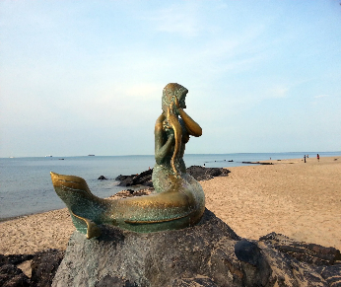
DAY 01 Arrival & City Highlights (HATYAI) (Meal by own)
- Arrival at Hat Yai Airport
- Meet & greet by local guide
- Visit Hat Yai Municipal Park
-Cable car to Golden Buddha (Phra Phutthamongkol Maharaj)
-Visit Kuan Im Goddess Statue and viewpoint
- Visit Khlong Hao Floating Market (Fri-Sun only)
- Explore Greenway Night Market or ASEAN night Bazaar
- Check-In hotel

DAY 02 Songkhla Old Town & Samila Beach (Breakfast / Lunch/Dinner)
- Breakfast at hotel
- Transfer to Songkhla Old Town
-Explore Street Art & Sino- Portuguese buildings
-Visit Songkhla National Museum
-Enjoy coffee at House No.1951 café or Lyn’s The Shanghai Café
- Visit Samila Beach & Mermaid Statue
- Visit Tang Kuan Hill (Lift to the viewpoint overlooking Songkhla Bay)
- Explore Red Mouse- Great Serpent (Nag Head) Landmarks

DAY 03 Phatthalung Nature &Local Lifestyle (Breakfast / Lunch/Dinner)
- Breakfast at hotel
- Travel to Phatthalung (1.5 hrs )
- Visit Thale Noi Waterbird Park-boat ride through lotus lake & birdwatching
- Photo stop at Thale Noi Bridge
- Lunch at View Yor Restaurant (lake View)
- Visit Khao Ok Talu, city landmark
- Transfer back to Hatyai

DAY 04 Hatyai- Departure (Breakfast)
- Breakfast at hotel restaurant
- to airport for your flight. Bringing back wonderful

